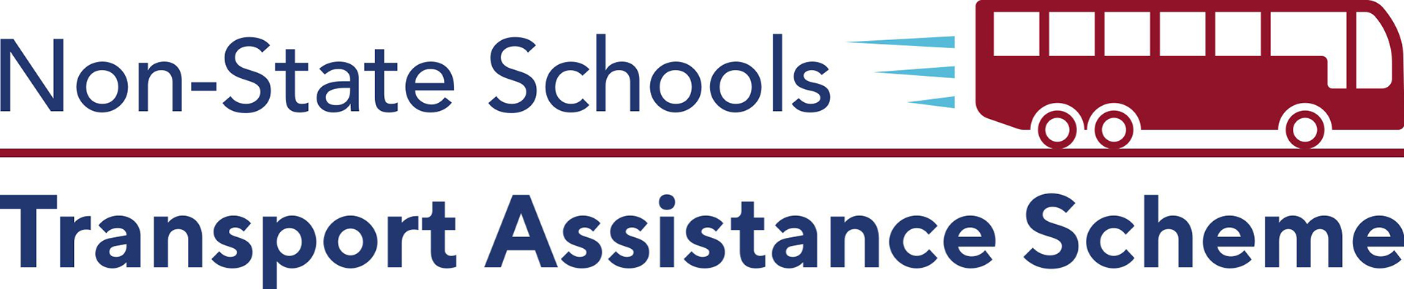

Student Travel Rebates
Semester 1

Visit our website to see if you qualify for our financial
assistance to help with the cost of transport and
apply at SchoolTransport.com.au during May.

Late applications cannot be accepted after 31st May.

Students With Disability

- Was your child included on the latest Commonwealth Census as a student with a disability requiring supplementary, substantial or extensive adjustments?
- Does your child’s Personalised Learning Plan confirm their transport needs are demonstrably different to those of their same aged peers by reason of their disability?
- Has your school’s learning support teacher assessed your child’s Travel Capability Rating as ‘semi-independent’ or more dependent?

Bus Fare Assistance

- Does your child attend a non-state school outside the Brisbane City Council boundary?
- Does your family spend more than $40/week* on bus/ferry fares to and from school (*$30/week if you, the parent, hold a concession card)?
- Does your child travel on a publicly available service not owned or chartered by the school?

